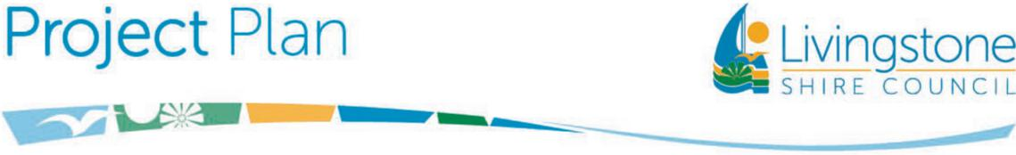

**Emu Park Waste Transfer Station Upgrade**

**Project Description:** The project involves the design and construction of an upgrade of the Emu Park Waste Transfer Station including construction of a new recycling drop-off area, new gatehouse and secure storage and improved road access.

The Construction has been awarded to 1One Group Pty Ltd.

**Reasons for Project:** The existing Waste Transfer Station is out of date with today’s waste management practices and the upgrade will greatly improve not only the functionality, but also the visual amenity of the site.

**Benefits of Project:** Improved road access and seagull lane (sorting of recyclables)  
New covered recycling drop-off and sorting area  
New gatehouse with secure storage  
Separation of public area and operational area

**Estimated Total Cost:** $650,000 (includes Design and Construction)   
**Commencement Date:** April 2025 (Construction)

**Duration of Project:** Four months

**Contact Officer:** Daniel Stroud, Infrastructure Projects

**Public Consultation:** Minimal – public awareness only – via Council Website, Council Facebook page, media publicity

**Potential Interruptions:** Works are planned to be completed on weekday mornings before the site is open to the public.  
Some areas will be fenced off from the public while construction is underway.  
The Transfer Station will remain open during the construction period.

